# ***The Brain-Friendly Workplace: Why Talented People***

# ***Quit and How to Get Them to Stay***

**LEADERSHIP ISN’T AN ART, IT’S A SCIENCE. BRAIN SCIENCE.**

**MEET FRIEDERIKE FABRITIUS**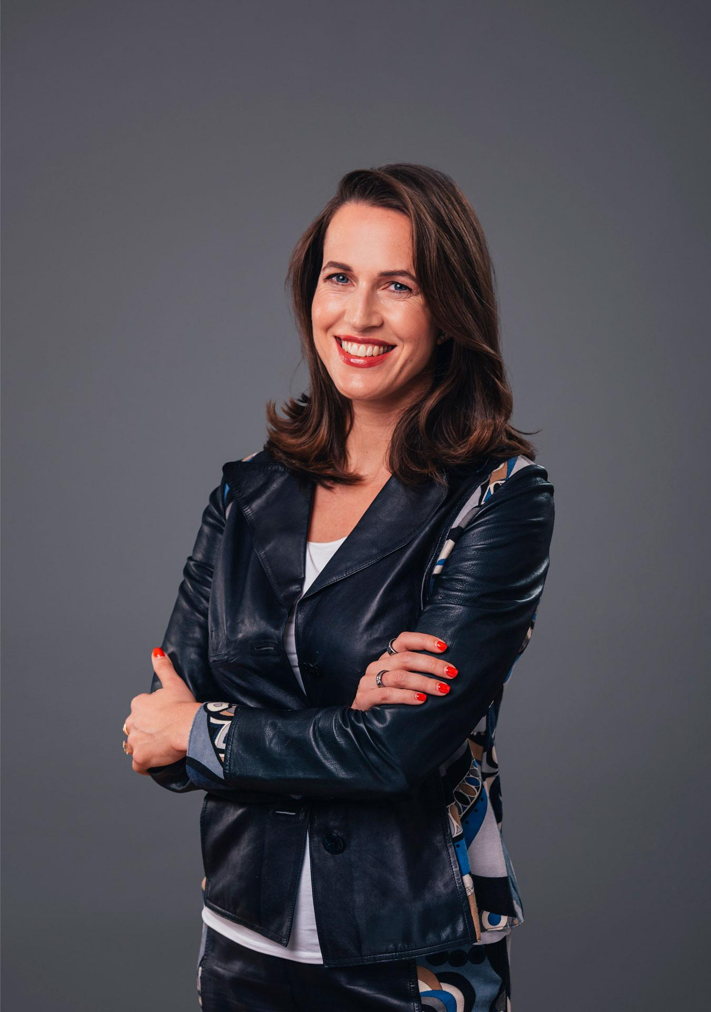

**WALL STREET JOURNAL & PUBLISHERS WEEKLY BESTSELLING AUTHOR!!**

***If you aren’t having fun at work, you are not performing at your very best.***

Friederike Fabritius, MS, is a neuroscientist and trailblazer in the field of neuroleadership. Her brain-based leadership programs have transformed how Fortune 500 executives think, innovate, and navigate change. Fabritius is a thought leader and keynote speaker, known for engaging global audiences at organizations like Google, Ernst & Young (EY), Boston Consulting Group (BCG), Adecco, Accenture, Deloitte, BMW, Bayer, SAP, Harvard Business Review, trivago, and Audi. An alumna of McKinsey & Company and the Max Planck Institute for Brain Research, she has served on the prestigious German Academy of Science and Engineering.

Ever since she can remember, Friederike has been curious about the way the brain works and why people behave the way they do. That’s why she chose to become a neuroscientist. But when she left the laboratory to take a job in management consulting, she was surprised to see the way that people in the business world were working. It wasn’t in line with what she knew from neuroscience about how the brain works best. Not even close.

That experience led her on a journey through neuroscience literature in pursuit of answers to some pressing questions. How can we work better? What are the principles that lead to better learning, improved collaboration, and the highest performance? And how can we make them applicable for busy executives? Ever since then, Friederike has worked with C-level executives from more than 164 countries in creating brain-friendly ways of working. It also led her to write her award-winning book *The Leading Brain*, which was published by Random House and has been translated internationally. Friederike is fluent in six languages.

Her latest book, ***The Brain-Friendly Workplace: Why Talented People Quit and How to Get Them to Stay*** (Rowman & Littlefield), is a Wall Street Journal and Publishers Weekly bestseller and is a smart, science-based approach to retaining your talent and making the world of work a better place.

**ABOUT THE BOOK**

***“Business leaders should make room on their desks for this guide.”–Publishers Weekly***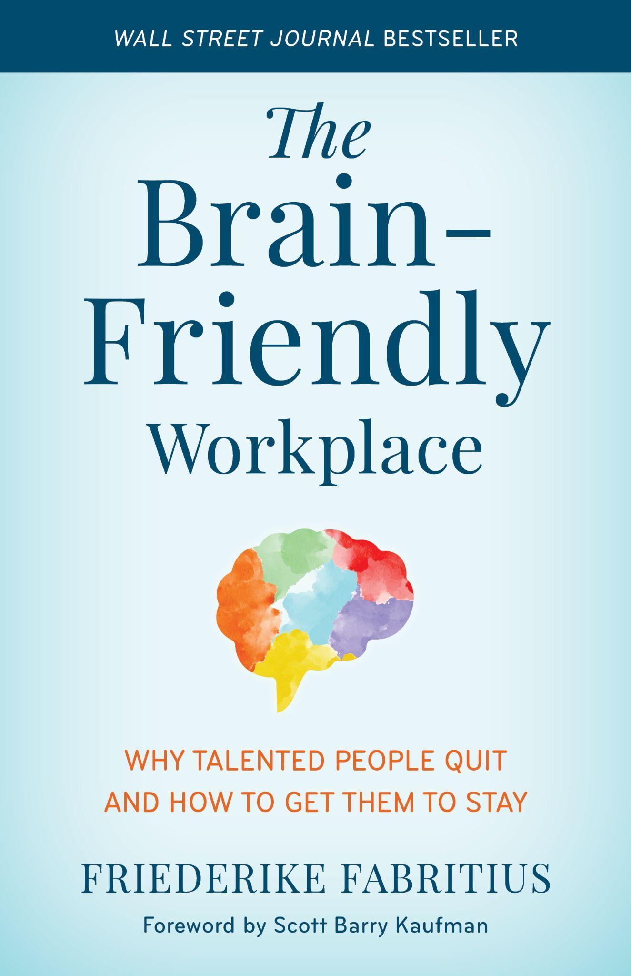

# ***The Brain-Friendly Workplace: Why Talented People Quit and How to Get Them to Stay***



The workplace of tomorrow is a hybrid ecosystem that thrives on flexibility and diversity of thought, enabling all employees to reach peak performance. Every person’s brain is different and by taking an inclusive view towards neurosignature diversity, organizations can get a competitive advantage.

However, today’s work isn’t working. Stress and burnout are driving talented professionals out of the workforce while the corporate standard of extreme hours, sleep deprivation, and nonstop travel proves unsustainable. But innovative leaders have a once-in-a century opportunity to create a future of work that’s better for everyone.

In ***The Brain-Friendly Workplace***, Friederike Fabritius offers a science-based and field-tested blueprint for tomorrow’s workplace. Leaders capable of enacting change or individuals searching for ways to work smarter will discover that even small and inexpensive changes can lead to advantages like better employee performance, higher job satisfaction, and stronger talent retention. If you have been longing for a better way of working where you and your people are both happy and productive, ***The Brain-Friendly Workplace*** can make that vision a reality.

***The Brain-Friendly Workplace: Why Talented People Quit and How to Get Them to Stay* is available on** [**Amazon**](https://www.amazon.com/Brain-Friendly-Workplace-Talented-People-Quit/dp/1538159538/ref=sr_1_1?crid=37OZZUTS1XTJD&keywords=brain+friendly+workplace&qid=1654742705&s=books&sprefix=%2Cstripbooks%2C110&sr=1-1) **and wherever fine books are sold.**

**DISCUSSION TOPICS**

* Fun, Fear, and Focus ® = Flow: All you need is a specific cocktail of neurochemicals to achieve peak performance – and be happier, too.
* Winning the talent war: Best practices for recruitment and retention
* Explaining the “neuro-gap” and how to nurture neurosignature diversity on your team
* 5 things you can do to create a more brain-friendly workplace (i.e., change the workplace, not the people!)
* 6 brain-friendly tips to increase productivity and improve overall well-being
* Better work-life balance: How to make a hybrid work situation work for you
* What “hustle culture” is vs. “outcome culture” and why our brains are not designed for the former (and how we can change hustle workplace cultures with outcome cultures)
* The art of saying “no” – based on neuroscience
* Why many DEI plans are missing the mark on gender diversity and how to change that
* Understanding neurosignature diversity: the next level of diversity for improved well-being, performance, and thriving in the workplace and beyond
* How sports, sleep, snacks, and sunlight give you better brain balance
* Improving your sleep to improve your brain function and overall health and well-being
* The “ten commandments” of great team relationships
* Brain hacks for instant well-being (i.e, ice baths are great for your brain!)
* How to reduce stress, anxiety and fatigue using neuroscience
* How to find your optimal stress point and make stress work for you
* Why creating an introvert-friendly workplace helps everyone
* How to cope with toxic behaviors and personalities in the workplace

**BOOK & EXPERT ENDORSEMENTS**

*“It's clear that the modern workplace isn't working for many people and that changes are imperative. Friederike outlines some practical science-based steps to get us from here to there: to cultivate a world that works well for all of us.”*

***– Riaz Shah, Senior partner, EY (Ernst & Young)***

*“Fighting burnout, finding focus, and giving your employees time to rest and recharge. It's obvious that the old ways aren't doing it. Friederike's book provides exciting new ways of rethinking the workplace that help both businesses and their employees to thrive.”*

***– Stephan Aarstol, author of The Five-Hour Workday***

*“This book is a great read for anyone involved in group decision making. It enhanced my understanding of diversity while highlighting how important it is. It focuses on taking care of yourself and each other, having fun, and why one should eat more chocolate. It made the work place come alive as a place you want to be.”*

***– Jeff Furman, Ben and Jerry’s Board of Directors, Emeritus***

*“Friederike Fabritius took us on a fascinating journey into the human brain and helped us understand how to use the discoveries of neuroscience in the daily management of ourselves, our teams. and our organizations. Her stage energy, incredible passion and impressive knowledge hypnotized the participants of our conference and led to a completely different view on many issues related to leadership.”* *–* ***Harvard Business Review***

*“Friederike's enthusiasm is contagious. Her neuroscience-based presentation on Fun, Fear and Focus® at the 2021 BDO Celebration was fun, accessible - and very popular with our global audience of virtual delegates. She demonstrated how to use neuroscience to help us work smarter and happier, perfectly fitting in with the celebratory tone of our event.”*

***– Julia Johnson, Global Brand & Marketing Director, BDO***

*“Friederike Fabritius is one of those rare speakers who has a natural ability to deliver complex ideas and science in a way that her audience can easily digest, understand and use for their own development. She’s concise, incisive and supremely focused. If you want to become better acquainted with your own brain and how to use it for peak performance there is no better guide. At the London Business Forum we call her Friederike ‘Fabulous’ Fabritius.”*

***– Brendan Barns, founder and CEO of London Business Forum***

*“I had the pleasure of seeing Friederike speak a few years ago and was blown away by her scientific approach. It directly translates into practical behaviors that anyone can utilize to become a better leader, colleague, and overall communicator. If you want to help your business or team improve their performance by understanding what drives us, you can’t ask for anyone better to connect and collaborate with.”*

***– Christopher Wade, Head of Employee Communications, HERE Technologies***

*“We worked with Friederike Fabritius on one of our recent TV produced client webinars. She is not only highly professional, but also very flexible and accessible...She really adapted her story to our needs; she took the time to listen to us, what we wanted to achieve with our program, and for who…not only a great professional in bringing an inspiring and customized keynote, but also the way in which she does it is truly first class level. I can highly recommend Friederike!”*

***– Barbara van der Vlugt-Witvoet, Global sponsoring & Events Expert, ING***

*“Friederike delighted and enlightened us with practical neuroscience-based advice on everything from peak performance to proper nutrition. She offered valuable practical tips for the professional and also private everyday life! The feedback from our participants was amazing and the numerous valuable insights are a real added value.”*

***– Ramona Sander, BMW***

*“What does neuroscience have to do with business management? Anyone who asks this question has never attended a lecture by Friederike. Our customers and our leadership were amazed by her profound knowledge and her entertaining presentation style.”*

***– Martin Kleinebrecht, Global Marketing Communications Leader, Johns Manville***

*“Incredible session, Friederike. Not only a masterclass on human cognition, but also on the power of being present and sharing human energy. You are our renaissance polymath.”*

***– Sophia Davies, PhD, Senior Architect BCG Platinion***

*“Friederike is a passionate leadership expert and a great storyteller! She delivered an impressive and engaging talk, which was both captivating and insightful! The talk has proven to be very useful in our ways of understanding team dynamics and increasing the productivity of project groups at trivago.”* ***– Anitta Krishan, Organizational Development, trivago***

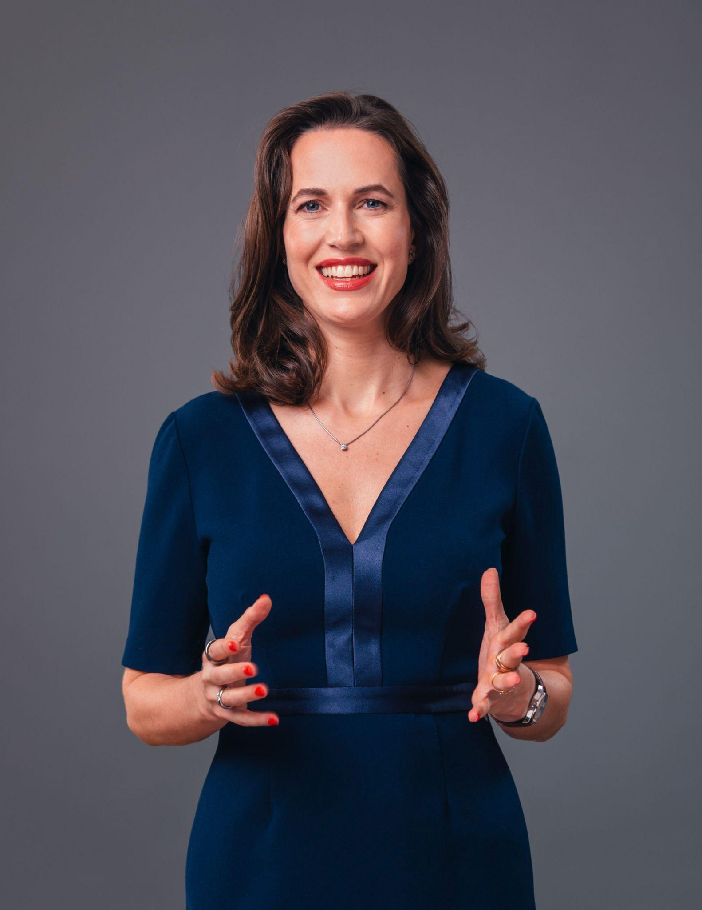

**APPEARANCES/KEYNOTES**

How does the brain work? And how can you use this knowledge to improve your well-being and performance? German best-selling author and acclaimed neuroscientist Friederike Fabritius provides science-based insights that you can put into immediate practice in order to work and live smarter, better, and happier. Her unique talent is to take complex scientific insights and make them easy and accessible to anyone. Here are some of Friederike’s most popular keynote presentations:

* [**Take Charge of Your Emotions**](https://www.youtube.com/watch?v=liu3cbEB3H8)
* [**Neuroleadership - A new approach**](https://www.youtube.com/watch?v=2g4XhlLZ5ak)
* [**The Neuroscience of Great Relationships**](https://www.youtube.com/watch?v=IIl72T7aKHk)
* [**Taking Control of Your Life**](https://www.youtube.com/watch?v=GfCKBUFMrc4)
* [**Friederike Fabritius at the Global Scrum Gathering in Vienna**](https://www.youtube.com/watch?v=yeAxNi-PUU8)

**CONTACT**

**Friederike is available for interviews, expert commentary, features, Q&As and select byline opportunities. For media inquiries, please reach out to** [**office@friederikefabritius.com**](mailto:office@friederikefabritius.com)**.**

**For more information on Friederike or *The Brain-Friendly Workplace*, visit:**

Website: <https://friederikefabritius.com/books/the-brain-friendly-workplace>

LinkedIn: <https://www.linkedin.com/in/friederikefabritius>

Twitter: <https://twitter.com/FriederikeFab>

YouTube: <https://www.youtube.com/c/FriederikeFabritius1>

Facebook/Meta: <https://www.facebook.com/FriederikeFabritius>

Instagram: @friederikefabritius (<https://www.instagram.com/friederikefabritius/>)

To book speaking/virtual events, contact:[office@friederikefabritius.com](mailto:office@friederikefabritius.com)

# # #